CTCP and CF-CTCP
Key observation for our improvement
kPEX introduced CF-CTCP and, in its ablation study, reported that CF-CTCP outperformed its own implementation of CTCP (called bad-CTCP). However, a closer inspection shows that the CTCP baseline used there was comparatively weak.
When CF-CTCP is compared against an optimized CTCP implementation from kPlexT, the result is reversed: CTCP performs significantly better.
Part | CTCP / kPlexT | CF-CTCP / kPEX
Graph format | CSR-style arrays | CSR-style arrays
Edge array | Correct CTCP reuses edges[] / compacts live edges to earlier slots | bad CTCP creates new graph only when remaining edges are half or less | reuses edge_to[] / compacts live edges to earlier slots
pstart array | reused in place | creates new_pstart, deletes old pstart
degree array | reused/updated in place | creates new_d, deletes old d
vertex IDs | remapped compactly using rid / out_mapping | remapped compactly using id_map / map_refresh_id
- Expensive triangle counting (Issue to both versions of kPEX)
  - Both kPlexT and kPEX precomputes triangle counts of edges
  - kPEX does not use degeneracy-oriented graph when computing initial triangle counts of edges, so intersections are more expensive due to long adjacency lists of high-degree vertices
  - kPEX does not use N+() to count each triangle only once, but count 3 times.
- Expensive reverse edge lookup (Issue unique to bad CTCP)
  - A key implementation issue in CTCP-style reductions is that each undirected edge is stored as two directed adjacency entries. When deleting an edge $\left\{u , v\right\}$, the algorithm must update both copies, so after finding the entry for $u→v$, it must also locate the reverse entry $v→u$.
  - This reverse-edge lookup can be implemented either by scanning the opposite adjacency list or by maintaining a direct reverse pointer. The former introduces extra linear-search overhead during repeated edge deletions and triangle-count updates, while the latter gives $O(1)$ access to the reverse copy once the forward entry is known.
  - The released kPEX baseline (bad) CTCP implementation uses repeated adjacency-list scans for this reverse-edge lookup. In contrast, its CF-CTCP implementation uses an auxiliary reverse-edge mapping, enabling constant-time access to the opposite edge copy. This is also the approach used in the well-engineered CTCP implementation of kPlexT.
  - Thus, the observed advantage of CF-CTCP over the kPEX baseline CTCP mainly come from an implementation asymmetry (unfairness) rather than the pruning rule alone. A fair comparison should equip baseline CTCP with the same $O(1)$ reverse-edge lookup used by CF-CTCP and kPlexT, so that the evaluation isolates the algorithmic contribution of CF-CTCP from avoidable adjacency-list scanning overhead.

Why baseline CTCP implementation of kPEX is bad:
A subtle implementation issue in CTCP-style reductions is reverse-edge lookup: since each undirected edge is stored as two directed adjacency entries, deleting $\left\{u , v\right\}$ requires locating both $u→v$ and $v→u$. In the released kPEX code, the baseline CTCP implementation appears to locate the reverse copy by repeatedly scanning the opposite adjacency list, while CF-CTCP uses an auxiliary reverse-edge mapping to access it in $O(1)$ time. This optimization is not specific to CF-CTCP; it is also used in kPlexT’s CTCP implementation. Therefore, comparisons against the kPEX baseline CTCP may conflate CF-CTCP’s algorithmic improvements with avoidable implementation overhead, and a fair baseline should use the same $O(1)$ reverse-edge lookup.
Why kPlexT’s CTCP is faster than kPEX’s CF-CTCP:
One reason kPlexT’s CTCP can be faster than kPEX’s CF-CTCP is that, although both methods precompute edge triangle counts, they do so with different graph representations and counting strategies. kPlexT computes these counts on a degeneracy-oriented graph, where intersections are performed over forward-neighbor sets $N^{+}(⋅)$; this avoids scanning long adjacency lists of high-degree vertices and counts each triangle only once. In contrast, kPEX computes initial triangle counts on the original undirected adjacency lists, so intersections involving high-degree vertices can be substantially more expensive. Moreover, because kPEX does not restrict counting to $N^{+}(⋅)$, each triangle is effectively counted once for each of its three edges, adding further overhead. Thus, kPlexT’s faster CTCP performance is partly explained by a more efficient oriented triangle-counting implementation rather than by the pruning rule alone.
Another reason is:
pstart array | reused in place | creates new_pstart, deletes old pstart
degree array | reused/updated in place | creates new_d, deletes old d

Method review from kPEX
Key theorem: Given the integer k and the lower bound lb, both CF-CTCP and CTCP reduce the input graph to the maximal subgraph that is (lb + 1 − k)-core and (lb + 3 – 2k)-truss.
CTCP repeatedly does:
full truss pruning reaches a fixed point
then remove one bad vertex
then truss may be invalid again
repeat
kPEX’s claim: This can waste work, because truss pruning is expensive: it requires triangle/common-neighbor computations on edges that may later disappear when their endpoint vertices are removed by core pruning.
CF-CTCP reverses the order:
full core pruning reaches a fixed point
then remove one bad edge
then core may be invalid again
repeat
kPEX’s claim: The intuition is that core pruning is cheaper and can quickly remove many low-degree vertices. Once those vertices are removed, their incident edges disappear too, so the later truss pruning is performed on a smaller graph.
So the key message of Fig. 2 is:
CTCP does expensive edge pruning before removing obviously weak vertices;
CF-CTCP removes weak vertices first, then applies expensive edge pruning only to the remaining graph.
Both methods aim to reach the same reduced subgraph satisfying the required core and truss constraints, but CF-CTCP is designed to avoid unnecessary truss computations.

Note: It is not “full global truss recomputation vs full global core recomputation” every time. CF-CTCP is queue/incremental-style. In Algorithm 4, it keeps removed edges in $Q_{e}$, updates only affected triangle counts, and RemoveEdge deletes one bad edge, then runs core pruning from the consequences of that deletion.
The fair interpretation is:
CTCP idea:
after truss effects are propagated, remove one bad vertex
CF-CTCP idea:
after core effects are propagated, remove one bad edge
So Fig. 2 is a conceptual scheduling diagram, not a literal implementation trace.
Their claim is believable in this narrower sense: CF-CTCP can avoid triangle updates for edges incident to vertices that core pruning will delete anyway. They explicitly say the gain comes from not computing triangle counts for edges removable by core pruning and not traversing triangle updates when both endpoints are removed by core pruning.
But I would not overstate it as a general dominance claim. If CTCP is implemented with an optimized seeded/incremental core-truss co-pruning procedure, the gap may shrink or reverse. The paper’s claim is mainly against their CTCP baseline and their cost model.

Issue 1: Degeneracy-Oriented Triangle Counting

Triangle counting without redundancy
$N^{+}(u)$ means the forward neighbors of vertex $u$.
Given an ordering of vertices, usually degeneracy order, $N^{+}(u)$ contains only neighbors that appear after $u$ in that order.
Input:
oriented graph G⁺
adjacency lists N⁺(u)
triangle_count = 0 # for the graph, not for each edge
for each vertex u:
for each v in N⁺(u):
# intersect forward neighbor lists
for each w in intersection(N⁺(u), N⁺(v)):
triangle_count += 1 # can be changed to 3 edge triangle count increment
More explicitly, using sorted lists:
for each vertex u:
for each v in N⁺(u):
A = N⁺(u)
B = N⁺(v)
i = 0
j = 0
while i < |A| and j < |B|:
if A[i] < B[j]:
i += 1
else if A[i] > B[j]:
j += 1
else:
w = A[i]
count triangle (u, v, w)
i += 1
j += 1
For edge support of $\left(u , v\right)$, every common neighbor $w$ should count, including:
w < u, w < v
So, degeneracy-oriented triangle counting does not mean “ignore $w<u,v$ forever.”
It means:
The triangle $\left(u , v , w\right)$is discovered only once, usually from the lowest-order vertex, but when discovered, it updates the triangle support of all three edges.
So conceptually:
if triangle (w,u,v) is found once:
support(w,u)++
support(w,v)++
support(u,v)++
That is how degeneracy-oriented counting can still correctly compute triangle(u,v).
But in their kPEX CF-CTCP code, they do not implement that degeneracy-oriented “count once and update three edges” style.
They compute support for each edge directly by w ∈ N(u) ∩ N(v), for the current edge $\left(u , v\right)$.
Summary:
Degeneracy-oriented triangle counting can speed up support computation
only if each discovered triangle updates all involved edges.
The kPEX CF-CTCP code instead computes common neighbors directly for each edge.

In CTCP paper https://www.vldb.org/pvldb/vol16/p127-chang.pdf:
Before Algorithm 3:
initialize Δ(e) = triangle support of every edge e
this can be done efficiently using degeneracy-oriented triangle counting with N+(u)
Inside Algorithm 3:
use ordinary current neighborhoods N(u), N(v)
maintain Δ after edge/vertex deletions
Final words:
- Using N+() avoids redundant triangle counting (3x)
- Degeneracy order makes each vertex’s forward neighbor set small.
Degeneracy order chooses an order so that every vertex has at most about $d$ forward neighbors, where $d$is the graph degeneracy:
|N+(u)| ≤ d
Usually:
d << max degree
So intersections become much cheaper.

Issue 2: Graph Shrinking and Rebuilding Cost [SKIP]

What “graph shrinking and rebuilding” means
Graphs are stored as arrays, not as pointer objects. Usually:
pstart[u] ... pstart[u+1]-1
gives the range of edge_to[] containing the neighbors of vertex u.
When many vertices or edges are deleted, the array becomes dirty:
old adjacency list:
u: [3, 7, 8, 12, 20]
after deletion:
u: [3, deleted, 8, deleted, 20]
You can handle this in two ways.
One way is lazy deletion:
keep the old array
mark deleted edges/vertices
skip them during traversal
This avoids copying memory, but later scans may visit many dead entries.
The other way is rebuilding / refreshing:
create new compact vertex IDs
copy only surviving edges into a new compact adjacency structure
recompute pstart and degrees
This makes the graph smaller and cleaner, but costs memory movement.
- Lazy deletion is adopted by both CTCP and CF-CTCP within a call of CTCP pruning
- Rebuilding / refreshing is adopted by both CTCP and CF-CTCP at the end of CTCP pruning.

Comparison
Both implementations use CSR-like arrays and compact surviving edges into earlier positions.
CTCP is called initially, and after each top-level branch’s BnB (since we need to remove current pivot) before moving to the next top-level branch.
The CTCP implementation performs more in-place compaction, reusing the existing pstart/degree-style arrays during cleanup.
The CF-CTCP implementation also reuses the edge array, but its rebuild step explicitly remaps vertices, allocates new pstart and degree arrays, rewrites surviving edges into compact form, and deletes the old offset/degree arrays.
Thus CF-CTCP has somewhat heavier graph-refresh machinery, but it is not rebuilding a completely new edge array each time.
Part | CTCP / kPlexT | CF-CTCP / kPEX
Graph format | CSR-style arrays | CSR-style arrays
Edge array | reuses edges[] / compacts live edges to earlier slots | reuses edge_to[] / compacts live edges to earlier slots
pstart array | reused in place | creates new_pstart, deletes old pstart
degree array | reused/updated in place | creates new_d, deletes old d
vertex IDs | remapped compactly using rid / out_mapping | remapped compactly using id_map / map_refresh_id
(reason of skipping: why not reuse pstart/degree arrays for CF-CTCP?)

Why degree array?
If the graph is fully compact and static, degree can be obtained from pstart:
degree[u] = pstart[u + 1] - pstart[u];
So in a clean CSR graph, the degree array is redundant.
But in these pruning algorithms, the graph is dynamic. Edges/vertices are deleted lazily, often without immediately rewriting the CSR arrays.
Example:
pstart[u] ... pstart[u+1]-1
may still contain:
[alive edge, deleted edge, alive edge, deleted edge]
Then:
pstart[u + 1] - pstart[u]
is only the physical adjacency-list length, not the current live degree.
Representative instances showing performance difference of CTCP and CF-CTCP:

CTCP performs better (Total 178 instances where speedup is >= 2x)
Dataset | k | CTCP | CF-CTCP | speedup
bibd_22_8 | 3 | 0.9 | 58 | 64.91
bibd_22_8 | 2 | 1.1 | 62.4 | 56.78
bibd_20_10 | 2 | 1.1 | 61.7 | 53.74
bibd_20_10 | 9 | 1.2 | 43 | 36.15
trackers | 3 | 53.2 | 742.9 | 13.96
trackers | 2 | 56.8 | 646.8 | 11.38
soc-livejournal-user-groups | 6 | 164.8 | OOT | 10.92+
soc-livejournal-user-groups | 2 | 187.4 | OOT | 9.61+
rec-epinions-user-ratings | 2 | 4.6 | 42.3 | 9.1
soc-livejournal-user-groups | 4 | 200.8 | OOT | 8.96+
soc-FourSquare | 8 | 1.1 | 8.2 | 7.63

Below are all 6 failure cases, and total time is very small.

CF-CTCP performs better (Total 6 instances where speedup is >= 2x)
Dataset | k | CTCP | CF-CTCP | speedup
ship_003 | 8 | 1.3 | 0.2 | 7
pdb1HYS | 4 | 1.1 | 0.5 | 2.28
friendster | 20 | 7.5 | 3.5 | 2.16
Fault_639 | 2 | 1 | 0.5 | 2.13
pkustk13 | 3 | 1.9 | 0.9 | 2.08
soc-pokec | 20 | 3.4 | 1.7 | 2
All times are very small, so people do not care much. In fact, this holds for all experiments with speedup > 1.38; there are some where the time is not so small, but we additional time is less than 38%.

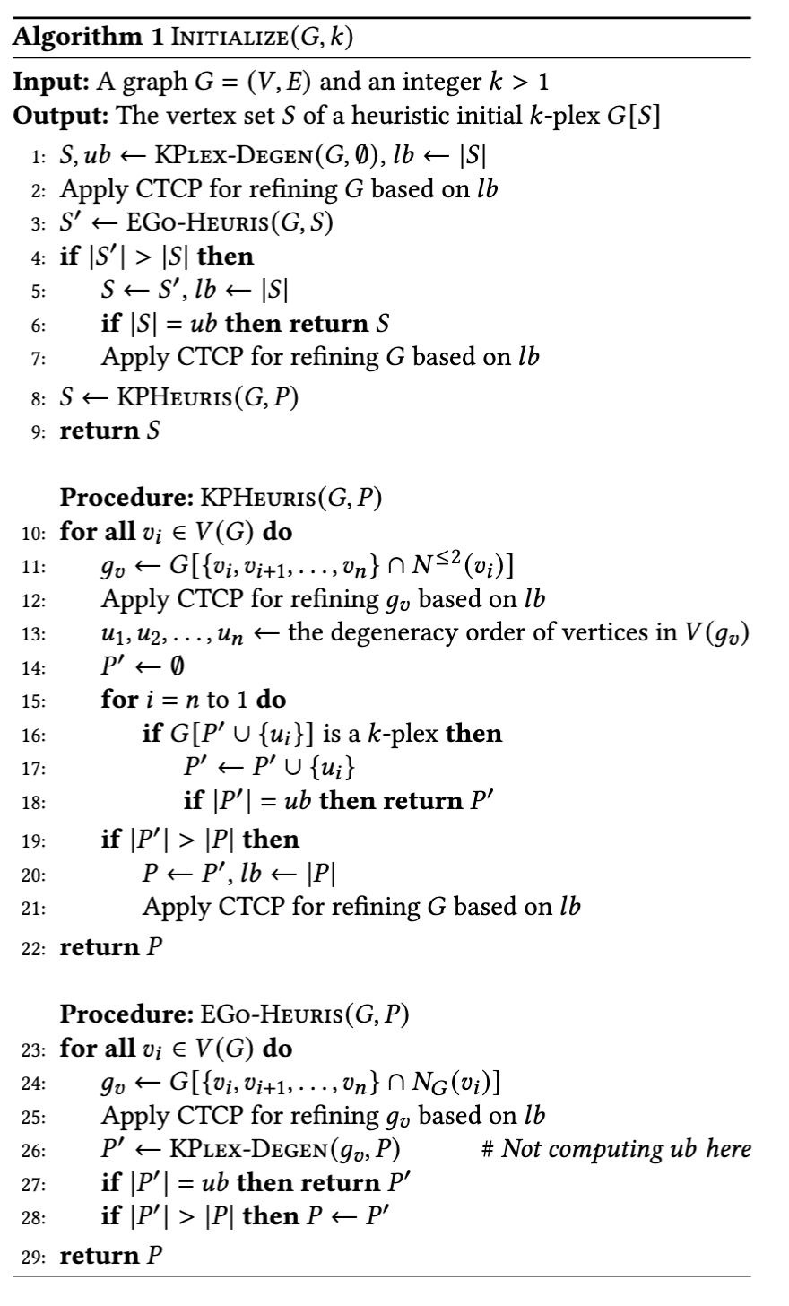
kPEX’s EGo poor baseline does not perform CTCP(g_{v})

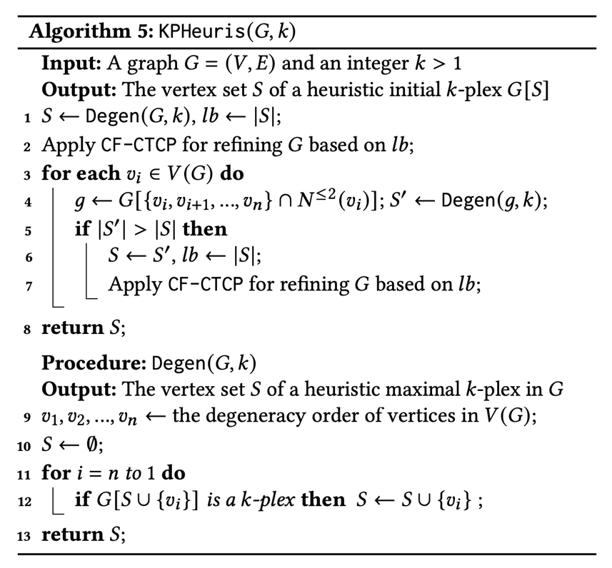
kPlexT’s EGo + KPHeuris run CTCP(g),
but not kPEX’s EGo
b CTCP()
EGo does not perform CTCP(G)
Run Ego first so |S| is larger, reduce cost of KPHeuris
kPEX introduced a heuristic method KPHeuris for computing a large initial k-plex and compared it against a basic heuristic implementation, referred to as kPEX-EGo, where KPHeuris is replaced by the existing heuristic method EGo-Degen.
However, we found that this version is a relatively poor implementation when compared with the optimized variant used in kPlexT, which we denote as EGo-opt
kPlexT’s EGo-opt is faster than (intentionally poor baseline) kPEX’s EGo (hence replaced) for two main reasons.
- EGo-opt is more memory-efficient.
  - EGo-opt reuses preallocated array-based buffers (CSR) across root (top-level) vertices. No repeated new/delete
  - kPEX-EGo rebuilds fresh vector<ui> and vector<vector<ui>> structures for every root vertex.
  - This repeated vector construction, reallocation, destruction increases memory-management overhead. Line 4 of algorithm 5 which is in the for loop of line 3
  - As a result, EGo-opt has better cache locality and lower constant-factor cost.
- EGo-opt performs stronger early pruning.
  - EGo-opt applies a threshold-based pruning step before degeneracy peeling.
  - This removes vertices that cannot contribute to a better k-plex early.
  - So the later peeling step runs on a smaller local subgraph.
  - kPEX-EGo instead builds the full ego subgraph first and only then applies peeling (i.e., Degen), which leads to more unnecessary work.
In short, EGo-opt is faster because it avoids repeated dynamic vector-based subgraph construction and reduces the local search space earlier.
We further observed that the execution of KPHeuris can be relatively expensive, although in some instances it is able to produce a larger initial \(k\)-plex than EGo-opt.
On the other hand, EGo-opt runs much more efficiently and usually incurs only negligible cost.
Based on this tradeoff, we found that a better strategy is to execute EGo-opt first and then invoke KPHeuris.
In this ordering, EGo-opt may already provide a stronger initial lower bound, which in turn helps KPHeuris by allowing it to start from a better incumbent solution and potentially reduce its subsequent search effort.

To write in paper
- Why Degen gives good/large init-kPlex? See screenshot below
- Why KPHeuris can give even larger init-kPlex than K? Line 7
- Why replace EGo implementation
- Why first run good-Ego, then KPHeuris

Issues: (not valid anymore)
- EGo should use 1-hop ego network for g, Degen uses kPlexS’s suffix method (besides not having Line 7)
- Now Akhlaque’s EGO is doing 2-hop egonet + new Degen from n to 1
- Try the right EGo for experiments also (EGo only, and EGo + KPHeuris)

KPlexT paper’s comments on their Ego (criticize KPlexS’s simple method, propose a version without Line 7)
https://dl.acm.org/doi/pdf/10.1145/3639318
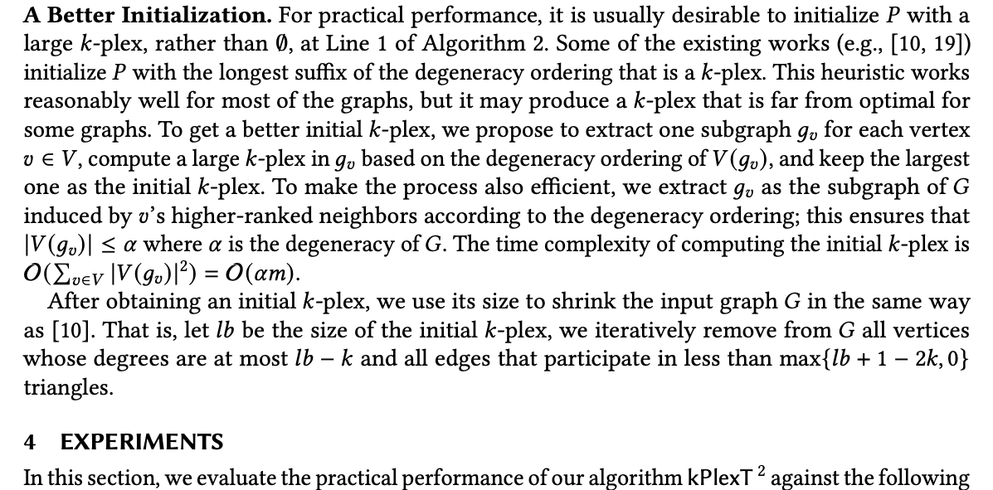

OUR VERSION
It is KPHeuris without Line 7. We now run this (faster because we do not do whole graph CTCP) first and then run Lines 3-7 again (with CTCP) with a tighter |S| bound.
Both also run CTCP(g) in Line 4, which is critical for performance.

KPHeuris’s EGo Baseline
KPHeuris uses a baseline EGo which runs KPHeuris without any CTCP (neither Line 4 nor 7), and computes new g each time as vec<vec>.

Dataset
- Total instances (dataset, k) = 32648
  - Total datasets = 2968
  - k values tested = 11 (2, 3, 4, 5, 6, 7, 8, 9, 10, 15, 20)
- All solved in less than 1s or preprocessing = 27779
  - All solved in less than 1sec = 10408
  - All solved in prep step = 17371
- All OOT (1800 sec) = 513
- Remaining instances for ML = 4356

